GRADE SPECIFICATION – OP Rounded Panel

PRODUCT NAME: PO Rounded Panel
SPECIES / GRADE: Oak and Walnut Standard – multiple options available
PANEL SIZE: 29”x 47.5” standard – multiple options available
PLANK WIDTH: Net: 2-1/8”
PLANK THICKNESS: 24/32”” with rounded edges – sticks only
PANEL THICKNESS 1 1/4”
MILLING PROFILE(S) Ship-lap design
PANEL DESIGN: 12-mm Baltic Birch substrate, with 2-1/4” randomized horizontal boards in the field. Panels can be rough cut or cut square to customer specification. Panels can be made with or without “butt joints” within the field, pricing will vary depending on final specification details.
STICK PRICING: All MLC paneling products can be sold as loose sticks (at a discount to the panelized price) for installation on-site to a suitable backer (e.g. plywood, mdf etc.)
Species Available and Specifications

Listed below are specifications for Select Oak and Walnut. These are standard products, can be stained in a variety of colors and textures, with pricing readily available. For other species, we will require 2-3 working days to finalize pricing and final spec.
Select Oak and Walnut Panel/Stick Characteristics:
HEARTWOOD/SAPWOOD CONTENT: Mixed, but from FAS material so primarily heartwood.
VERTICAL/FLAT SAWN CONTENT: Mixture of vertical and flat sawn grain
KNOT CONTENT: 80% of the board will be clear and free of knots. Knots over 1” will be defected out, knots under 1” will be filled and finished. All surfaces will be sound.
ADDITIONAL CHARACTER None
DESCRIPTION: Clean formal appearance. Predominately free of knots and other character defects found in lesser grades.
Finish Details: Standard - Water Clear Low VOC Water based urethane 10-sheen top coats.
Optional Class “A” Fire Treatment Available Upon Request
Optional Stain and Texturing Available Upon Request

Sample Image:
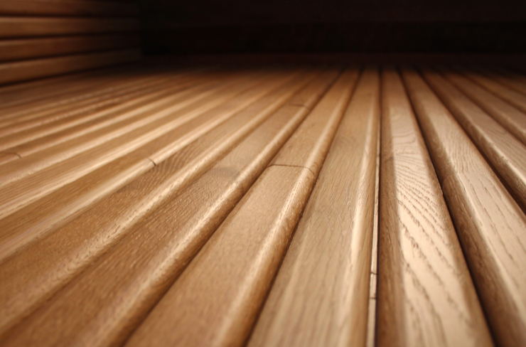
Detailed Dimensions
